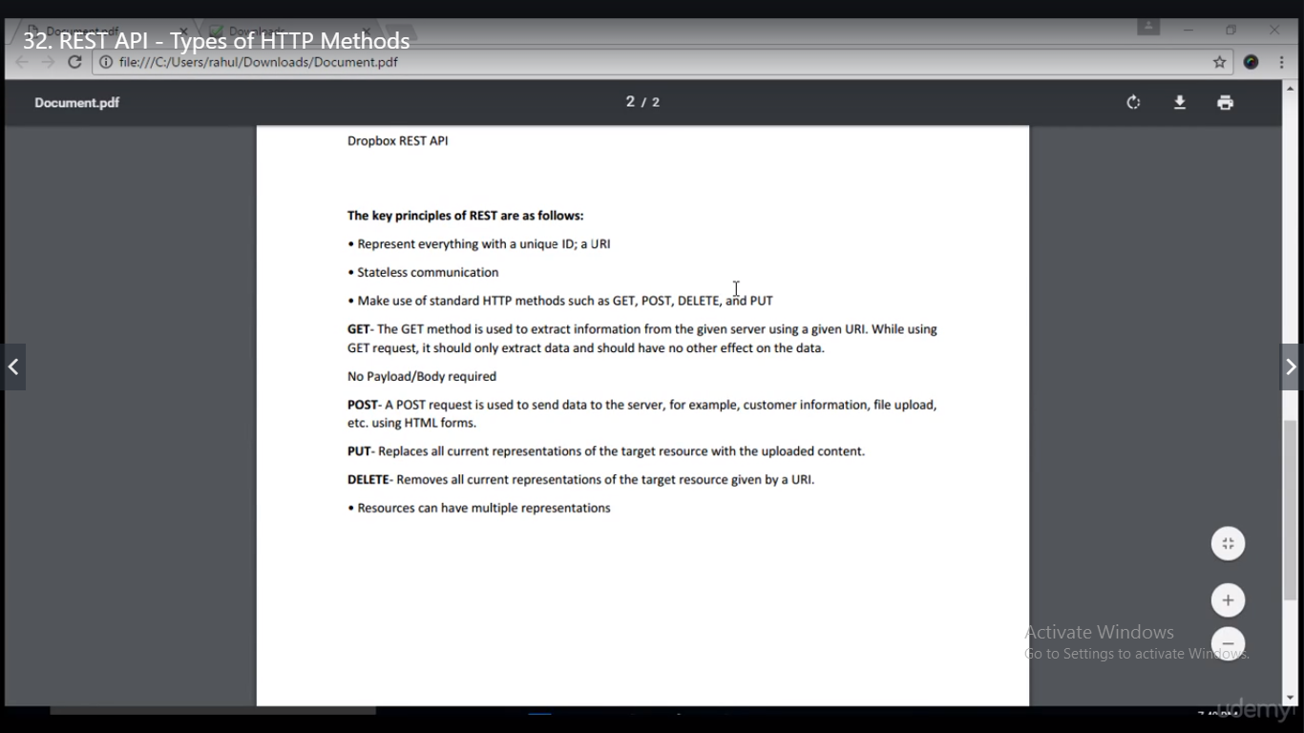

* URI=Base url+Resources+Parameters



* Here Base URL is [www.qaclickacademy.com](http://www.qaclickacademy.com) whereas /videos.rhp is resource
* Another example:

<https://www.google.com/search?q=soapui&rlz=1C1CHBD_enIN903IN904&oq=soapui&aqs=chrome..69i57j0l7.2702j0j8&sourceid=chrome&ie=UTF-8>

Baseurl: <https://www.google.com>

Resource : search

Parameter: <https://www.google.com/search?q=soapui&rlz=1C1CHBD_enIN903IN904&oq=soapui&aqs=chrome..69i57j0l7.2702j0j8&sourceid=chrome&ie=UTF-8>

* Between Resources and Parameter, there should be ? mark.
* Google uses rest api.

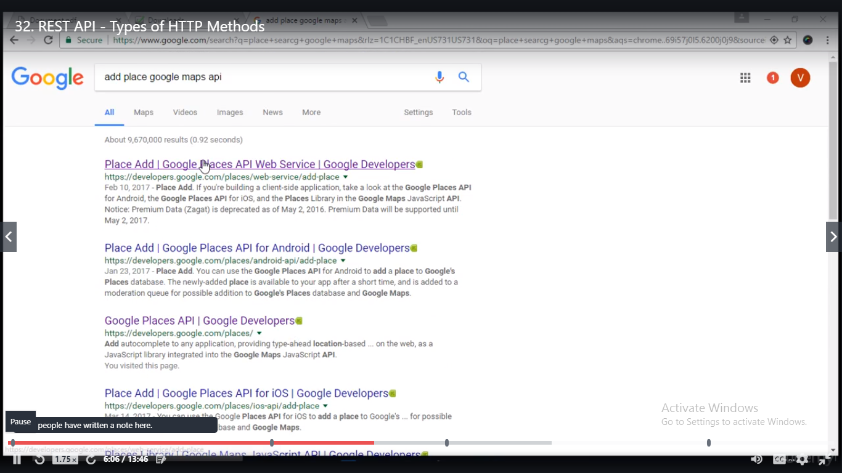

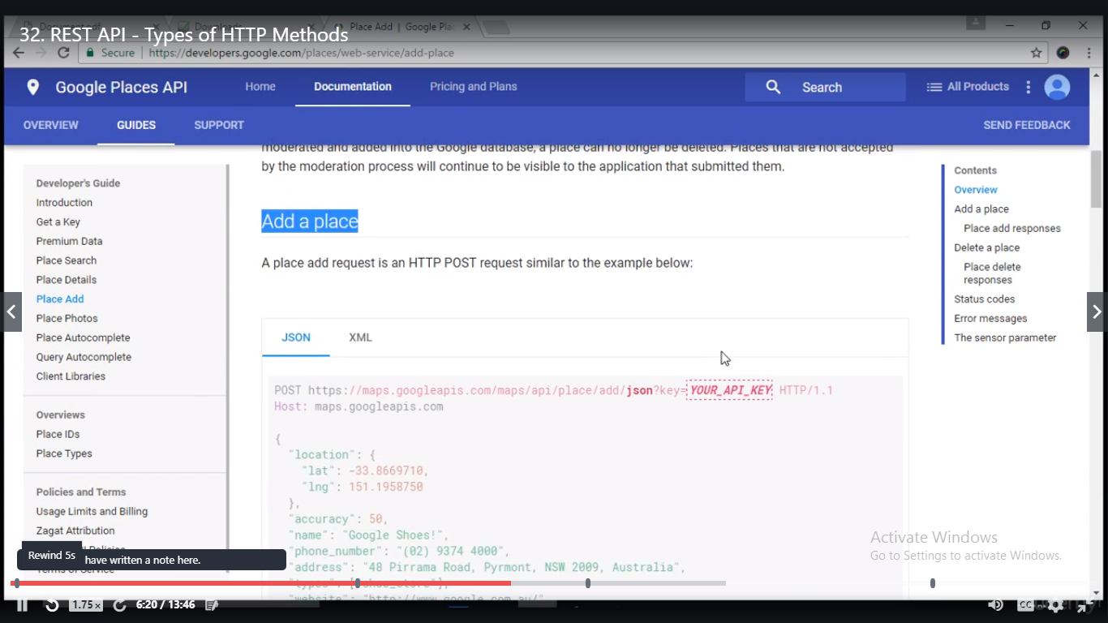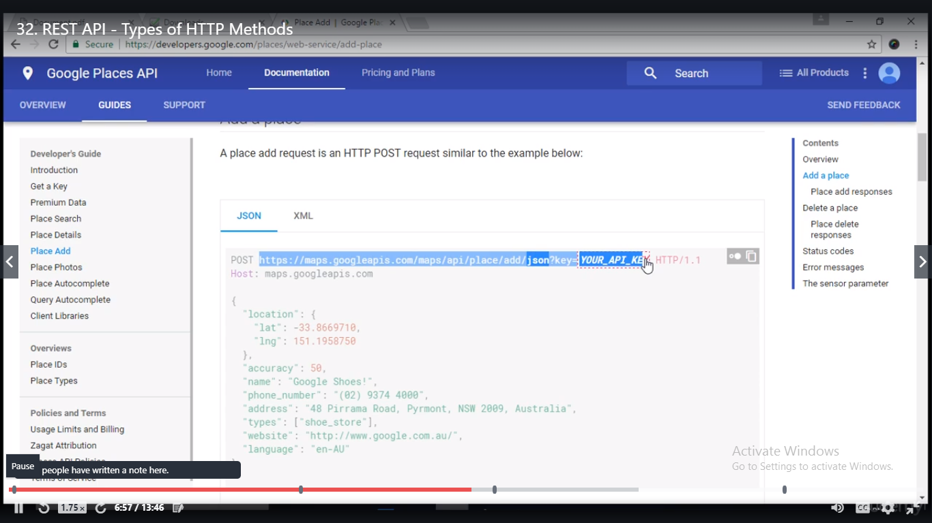

* Difference between get and post is in GET all the params which we are sending is visible in the URL. For POST we need a separate body section.